# **Format for uploading details in GitHub and Slack in word file format**

**Student Name: Shrinivasa**

**Class and Sec: VI B**

**USN: 4AL17CS092**

|  |  |  |  |  |
| --- | --- | --- | --- | --- |
| **Online Test Details** | | | | |
| **Subject** |  | | | |
| **Semester** | **VI - B** | | **Duration** | **Minutes** |
|  | |  | | |

**Encl: snapshot of the test result**

|  |  |  |  |
| --- | --- | --- | --- |
| **Pre-Placement Training Summary** | | | |
| **Pre placement training** | **9:00 am to 11:00 am - Programming in C**  **11:00 am to 1:00pm - Applications of python in DA and ML** | | |
| **Faculty** | **Mrs. Vivek Sharma,**  **Dr. Mohideen Badusha** | **Duration** | **4 hours** |

**Encl: snapshots of the daily class activities (at least two snap shot**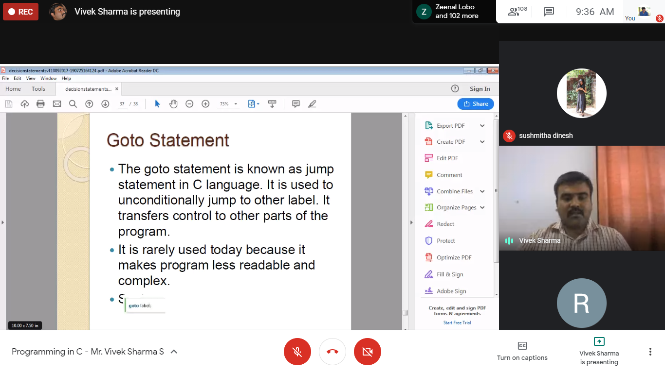

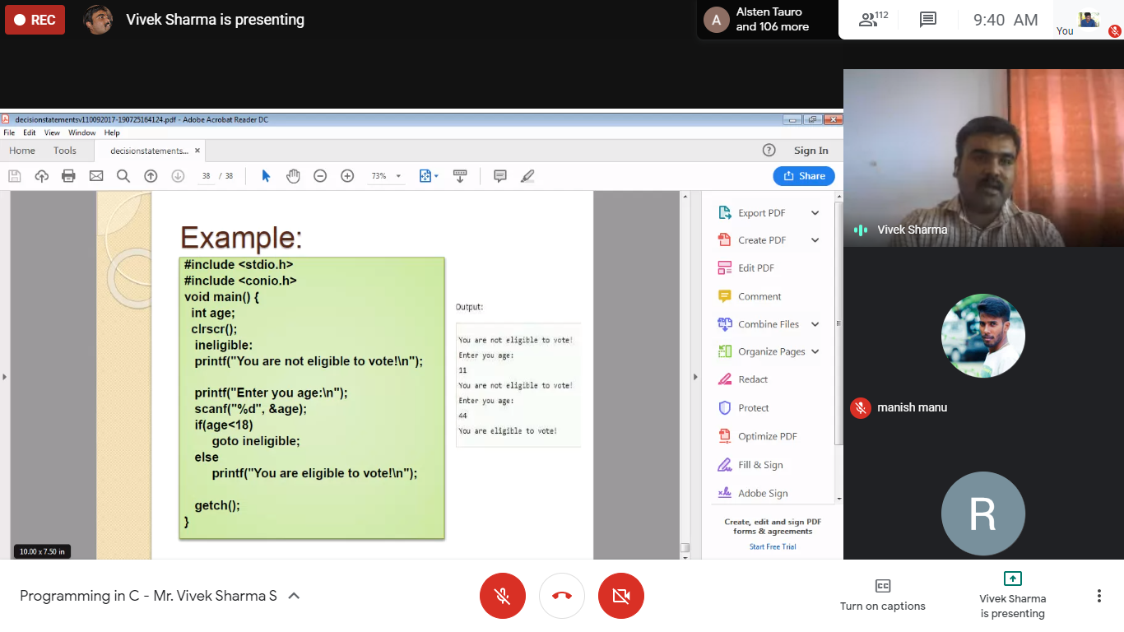

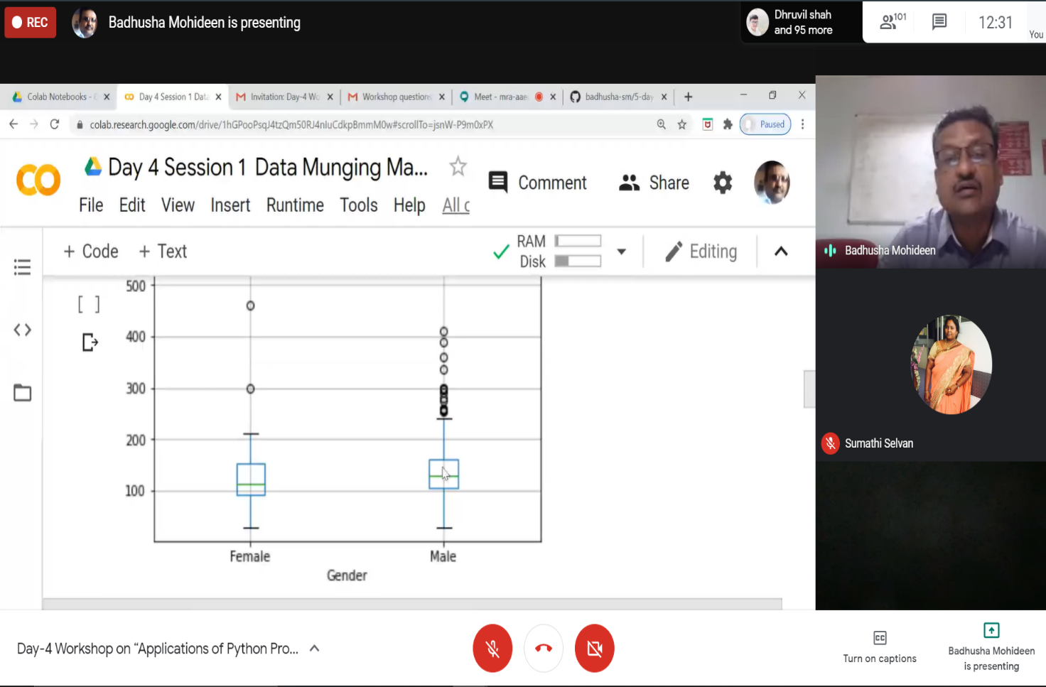

|  |  |
| --- | --- |
| **Coding Challenges** | |
| **Problem Statement:1. Examples and Exercises on python. (Linked Google-colab to GitHub)**  **2.Pro1(c)**  [**https://github.com/Shrinivasakunder/certification-and-online-coding**](https://github.com/Shrinivasakunder/certification-and-online-coding) | |
| **Status: Completed** | |
| **Uploaded the report both in GitHub & Slack** | **Yes** |

**Encl: snapshots of your response to challenge.**

**Write a C Program to generate first N Magic Numbers.**

#include <stdio.h>

#include <stdlib.h>

int main()

{

int n,b[100],i;

printf("Enter The N: ");

scanf("%d",&n);

for(i=0;i<n;i++)

{

int j=0,a=i+1;

while(a>0)

{

b[j++] = a%2;

a=a/2;

}

int l=j,k,s=0;

for(k=0;k<l;k++)

{

s=s+b[k]*pow(5,(k+1));

}

printf("%d\t",s);

}

return 0;

}

**Output:**

